Test Case: tc003_SPX_Dev5_Crear_Requisicion_Spot_Tipo_Cobro_CC_Urgent
Step 1 - Enter username and password and click to button Enter : Credentials Entered
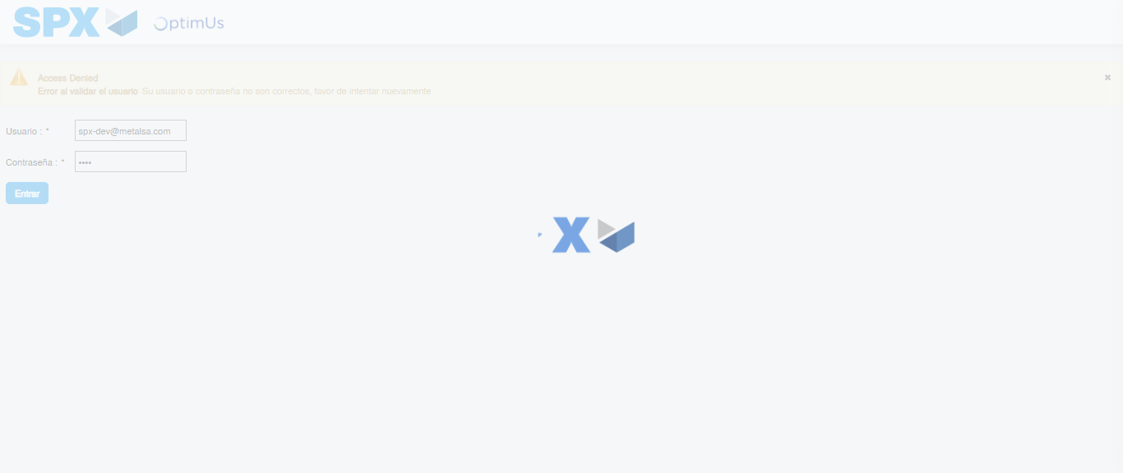Image file-name: QC_Testing-tc003_SPX_Dev5_Crear_Requisicion_Spot_Tipo_Cobro_CC_Urgent-1782239299223

Step 2 - Select to UEN and Access to Spot Buy Requisitions : UEN Correctly selected and Correct access
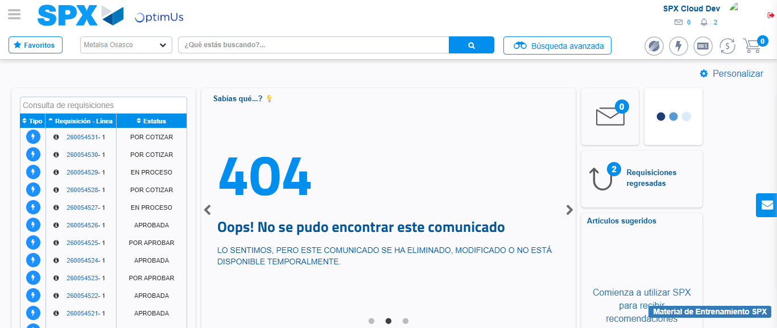Image file-name: QC_Testing-tc003_SPX_Dev5_Crear_Requisicion_Spot_Tipo_Cobro_CC_Urgent-1782239325360

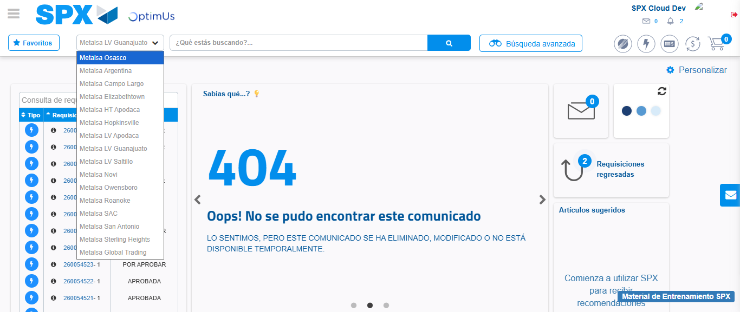Image file-name: QC_Testing-tc003_SPX_Dev5_Crear_Requisicion_Spot_Tipo_Cobro_CC_Urgent-1782239327908

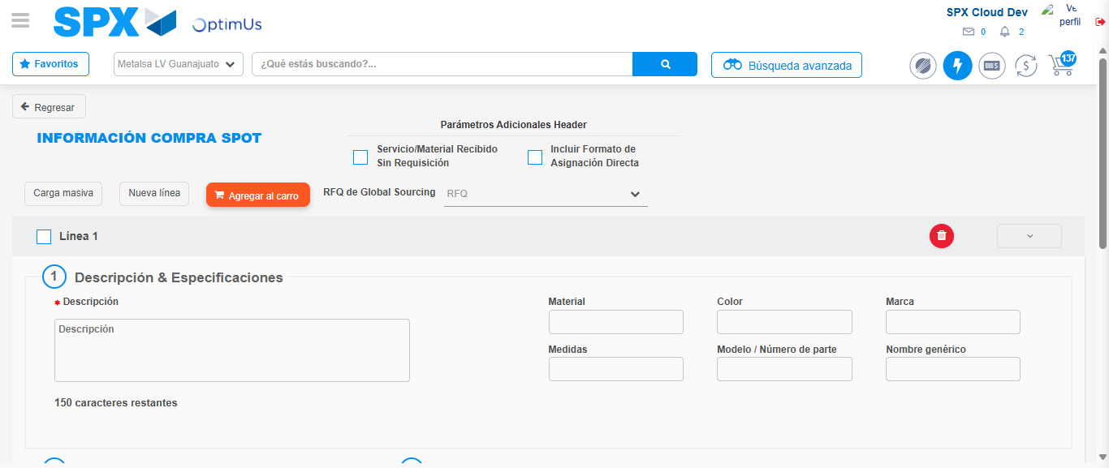Image file-name: QC_Testing-tc003_SPX_Dev5_Crear_Requisicion_Spot_Tipo_Cobro_CC_Urgent-1782239357886

Step 3 - Data Capture Spot Buy Requisition: Data captured correctly
Image file-name: QC_Testing-tc003_SPX_Dev5_Crear_Requisicion_Spot_Tipo_Cobro_CC_Urgent-1782239358092

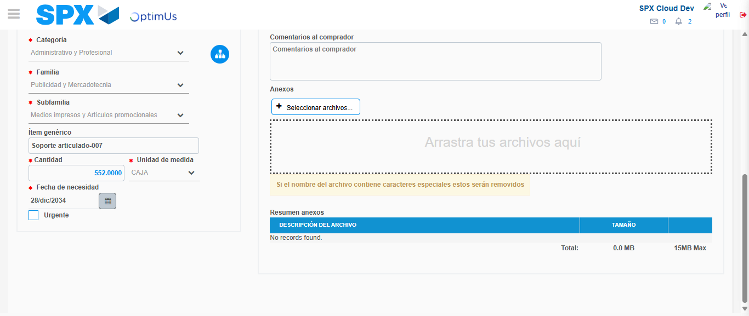Image file-name: QC_Testing-tc003_SPX_Dev5_Crear_Requisicion_Spot_Tipo_Cobro_CC_Urgent-1782239369104

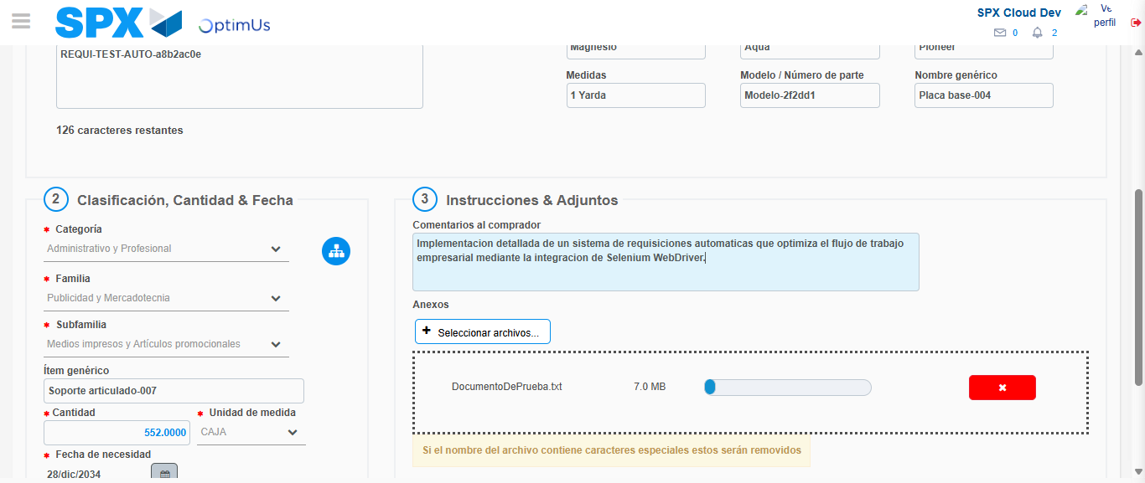Image file-name: QC_Testing-tc003_SPX_Dev5_Crear_Requisicion_Spot_Tipo_Cobro_CC_Urgent-1782239369814

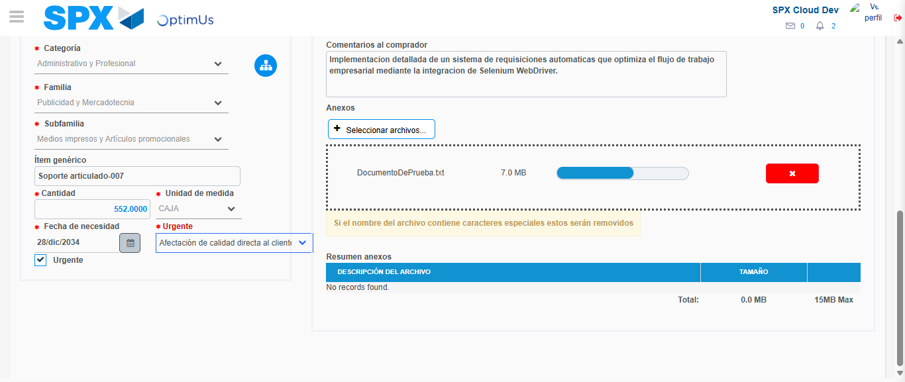Image file-name: QC_Testing-tc003_SPX_Dev5_Crear_Requisicion_Spot_Tipo_Cobro_CC_Urgent-1782239373399

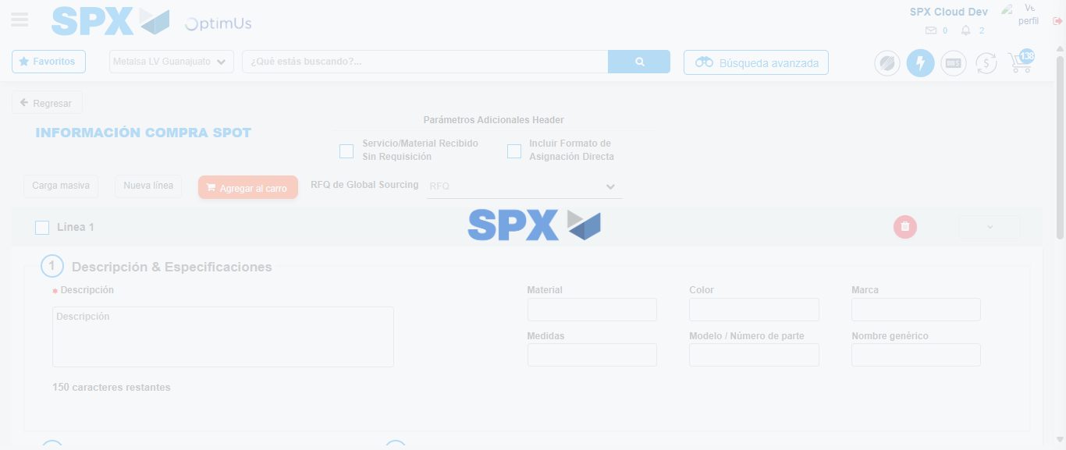Image file-name: QC_Testing-tc003_SPX_Dev5_Crear_Requisicion_Spot_Tipo_Cobro_CC_Urgent-1782239376908

Step 4 - Select to Requisition: Requisition Correctly selected
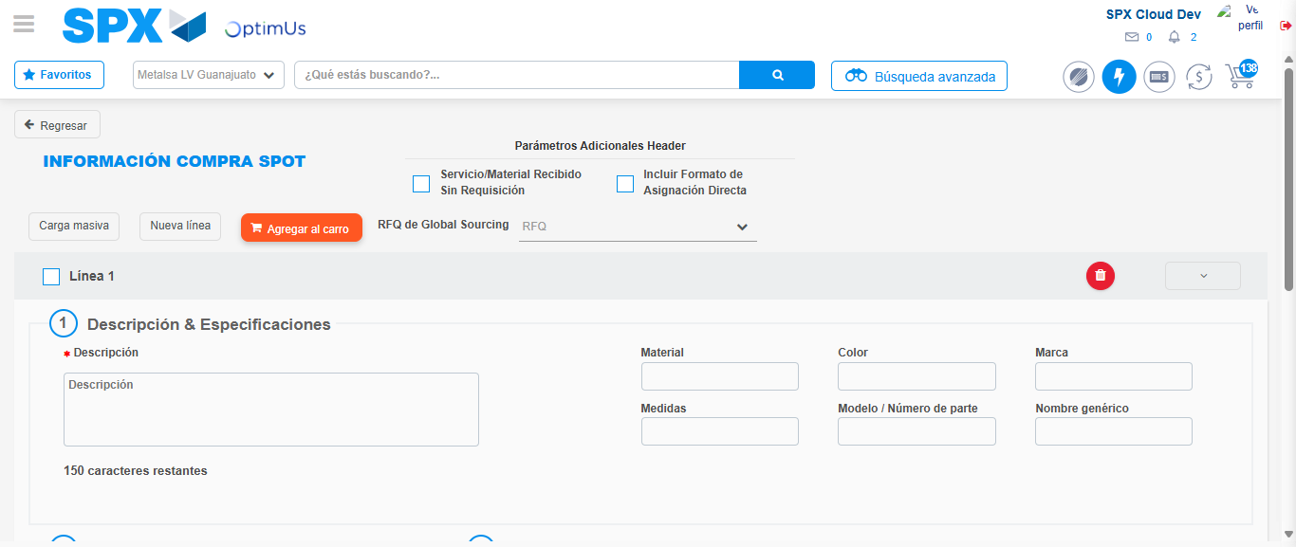Image file-name: QC_Testing-tc003_SPX_Dev5_Crear_Requisicion_Spot_Tipo_Cobro_CC_Urgent-1782239377124

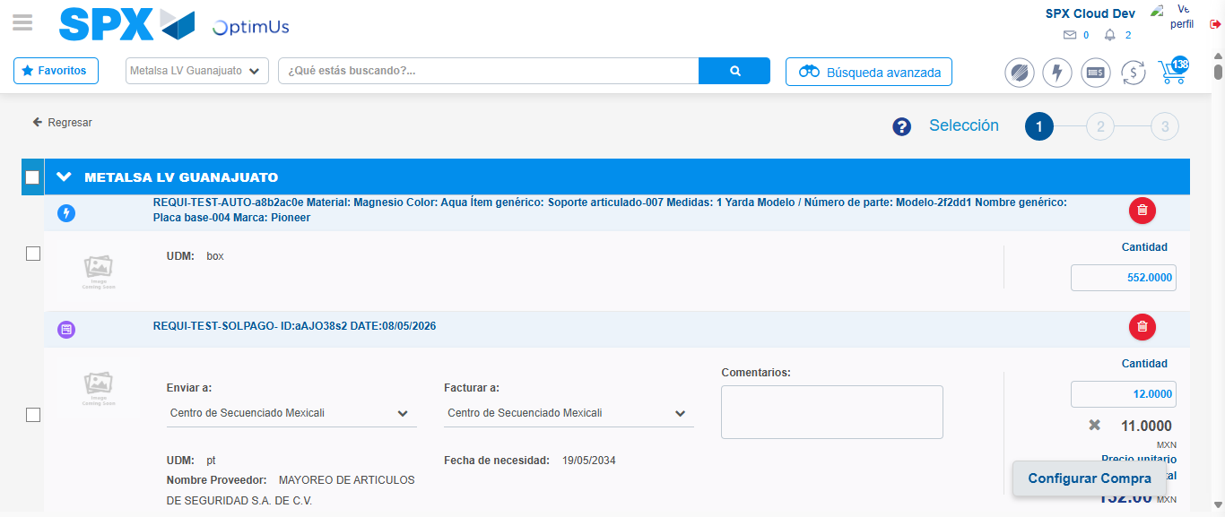Image file-name: QC_Testing-tc003_SPX_Dev5_Crear_Requisicion_Spot_Tipo_Cobro_CC_Urgent-1782239388669

Image file-name: QC_Testing-tc003_SPX_Dev5_Crear_Requisicion_Spot_Tipo_Cobro_CC_Urgent-1782239388921

Image file-name: QC_Testing-tc003_SPX_Dev5_Crear_Requisicion_Spot_Tipo_Cobro_CC_Urgent-1782239389131

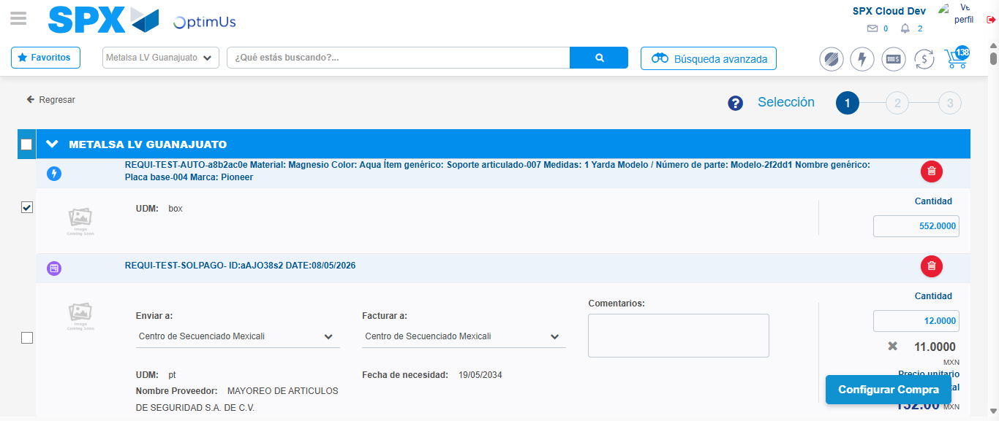Image file-name: QC_Testing-tc003_SPX_Dev5_Crear_Requisicion_Spot_Tipo_Cobro_CC_Urgent-1782239391064

Step 5 - Select Type Account For Requisition: Type Account Correctly selected
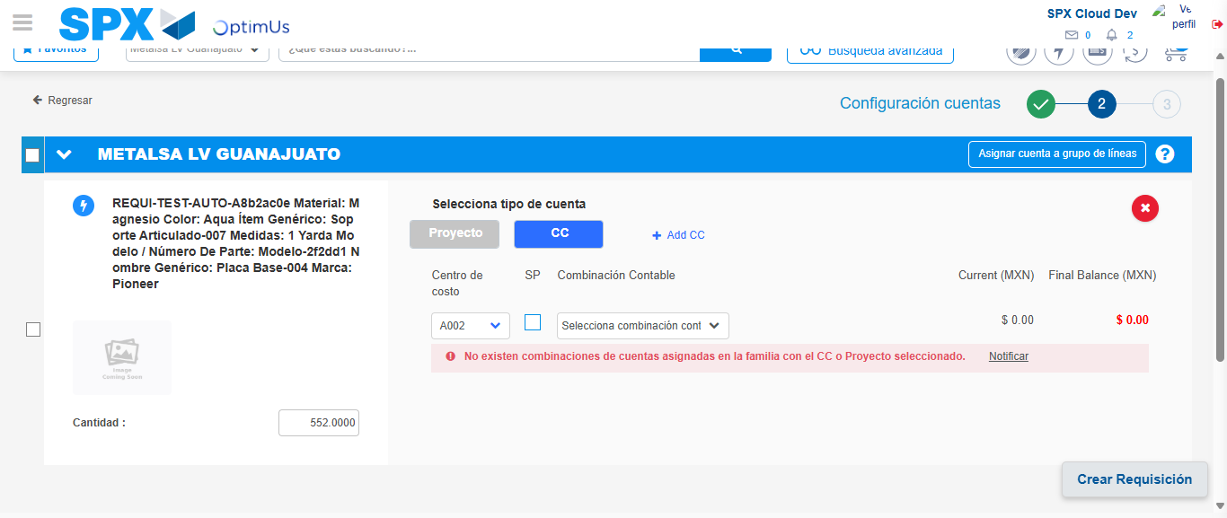Image file-name: QC_Testing-tc003_SPX_Dev5_Crear_Requisicion_Spot_Tipo_Cobro_CC_Urgent-1782239407608

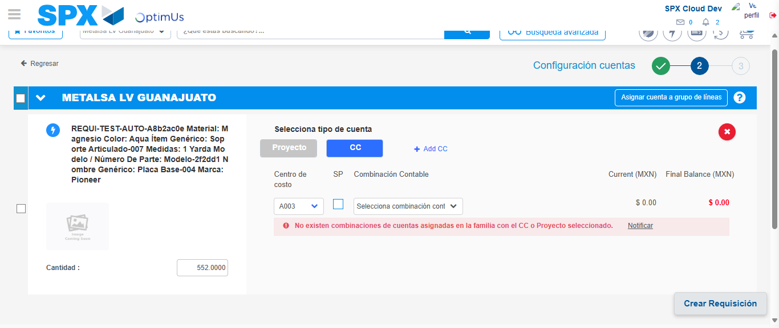Image file-name: QC_Testing-tc003_SPX_Dev5_Crear_Requisicion_Spot_Tipo_Cobro_CC_Urgent-1782239412863

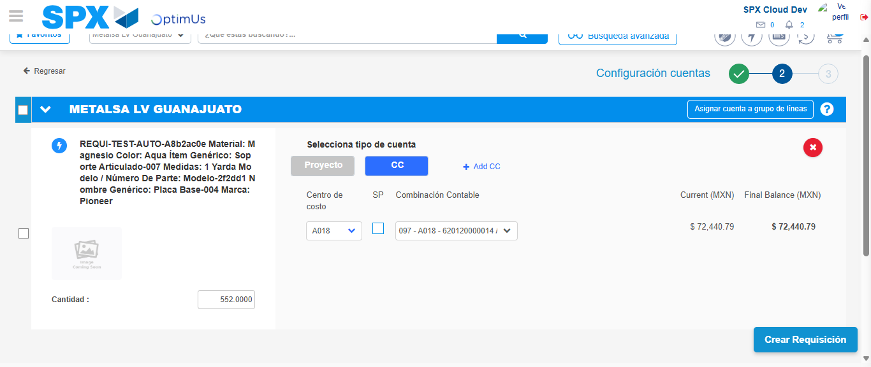Image file-name: QC_Testing-tc003_SPX_Dev5_Crear_Requisicion_Spot_Tipo_Cobro_CC_Urgent-1782239418197

Image file-name: QC_Testing-tc003_SPX_Dev5_Crear_Requisicion_Spot_Tipo_Cobro_CC_Urgent-1782239418394

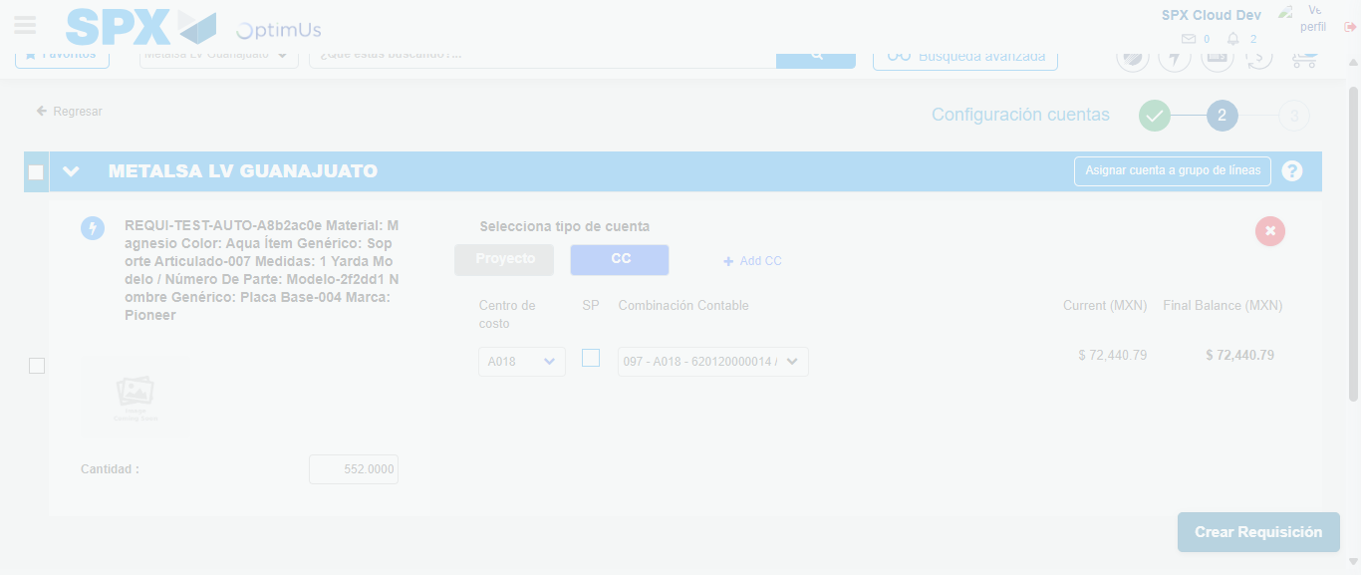Image file-name: QC_Testing-tc003_SPX_Dev5_Crear_Requisicion_Spot_Tipo_Cobro_CC_Urgent-1782239418799

Step 6 - Accept to Requisition: Requisition Accepted
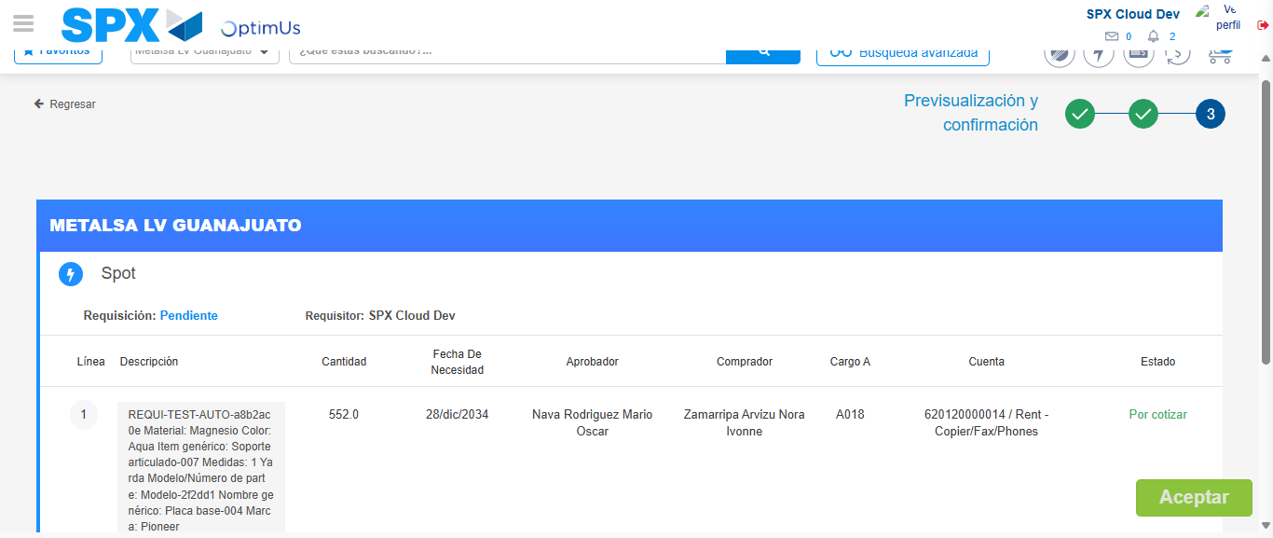Image file-name: QC_Testing-tc003_SPX_Dev5_Crear_Requisicion_Spot_Tipo_Cobro_CC_Urgent-1782239419584

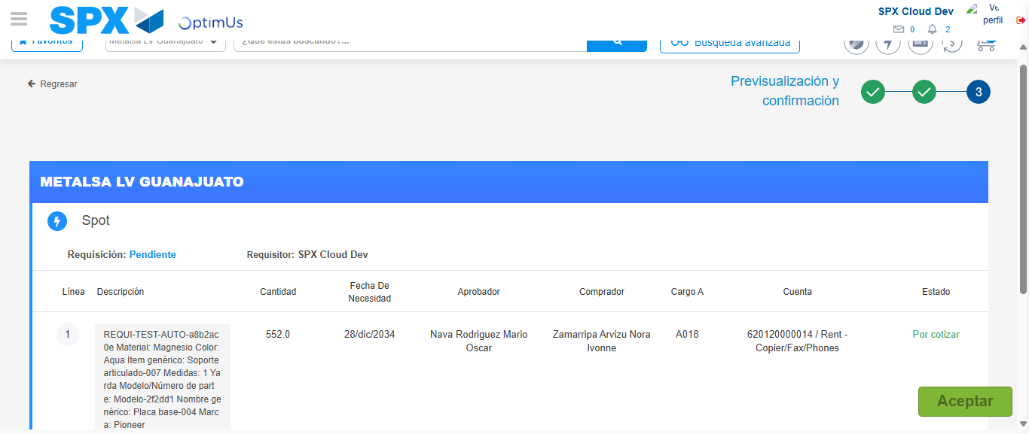Image file-name: QC_Testing-tc003_SPX_Dev5_Crear_Requisicion_Spot_Tipo_Cobro_CC_Urgent-1782239419869

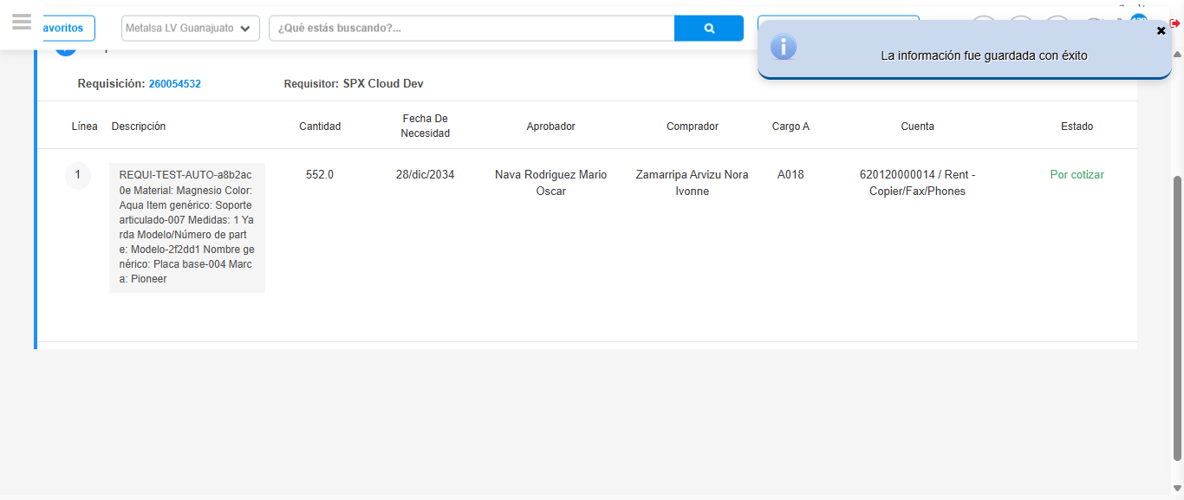Image file-name: QC_Testing-tc003_SPX_Dev5_Crear_Requisicion_Spot_Tipo_Cobro_CC_Urgent-1782239422872

Step 7 - Return to Main Page SPX : Return to Main Page SPX
Image file-name: QC_Testing-tc003_SPX_Dev5_Crear_Requisicion_Spot_Tipo_Cobro_CC_Urgent-1782239325360

Image file-name: QC_Testing-tc003_SPX_Dev5_Crear_Requisicion_Spot_Tipo_Cobro_CC_Urgent-1782239327908

Image file-name: QC_Testing-tc003_SPX_Dev5_Crear_Requisicion_Spot_Tipo_Cobro_CC_Urgent-1782239357886

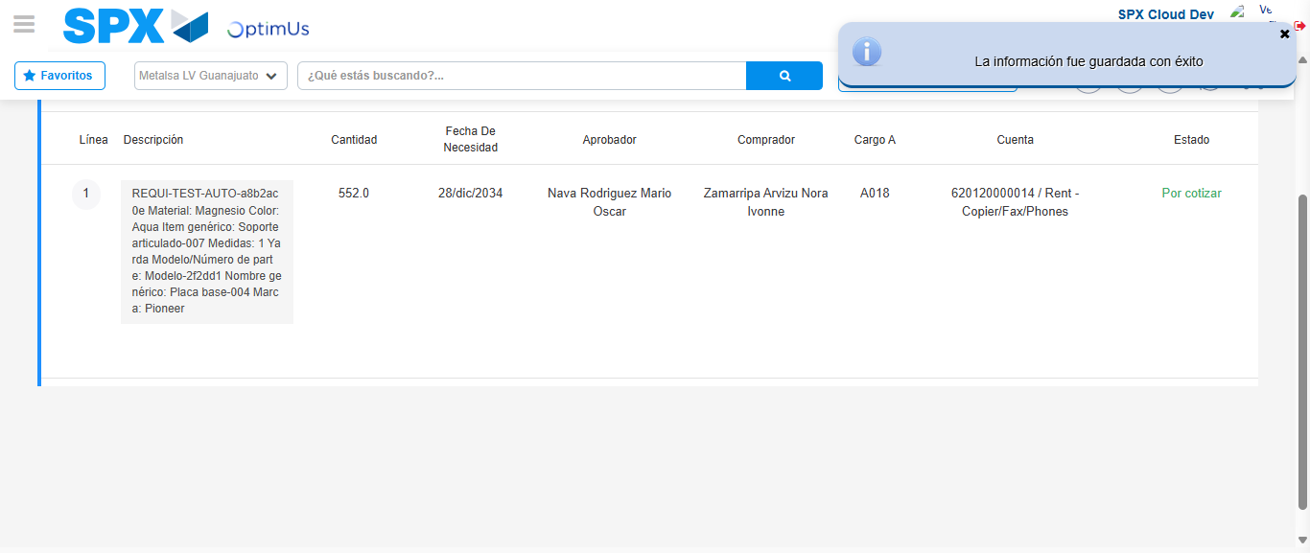Image file-name: QC_Testing-tc003_SPX_Dev5_Crear_Requisicion_Spot_Tipo_Cobro_CC_Urgent-1782239425100

Image file-name: QC_Testing-tc003_SPX_Dev5_Crear_Requisicion_Spot_Tipo_Cobro_CC_Urgent-1782239425280

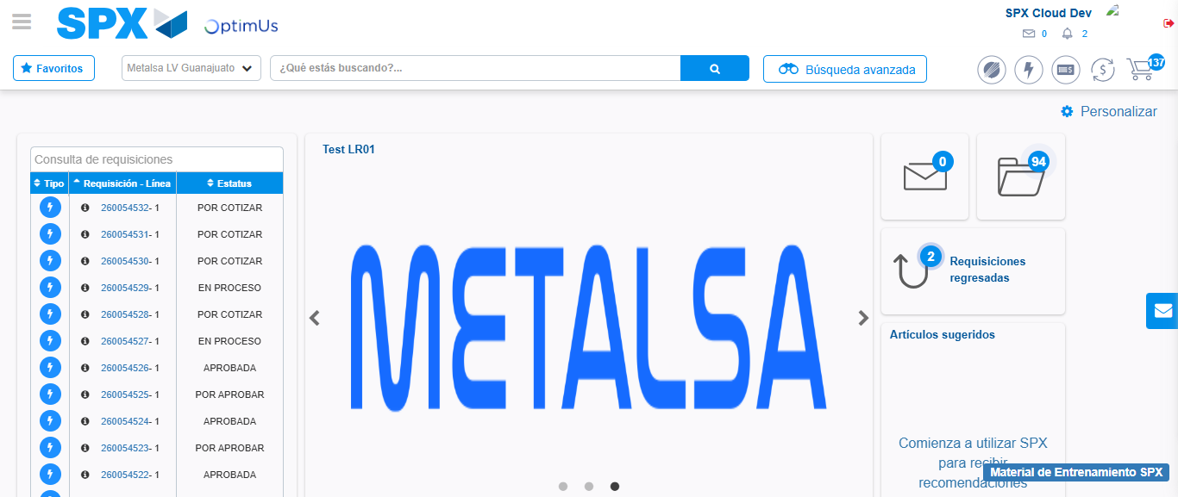Image file-name: QC_Testing-tc003_SPX_Dev5_Crear_Requisicion_Spot_Tipo_Cobro_CC_Urgent-1782239446298

Step 8 - Log Out : Log Out SPX
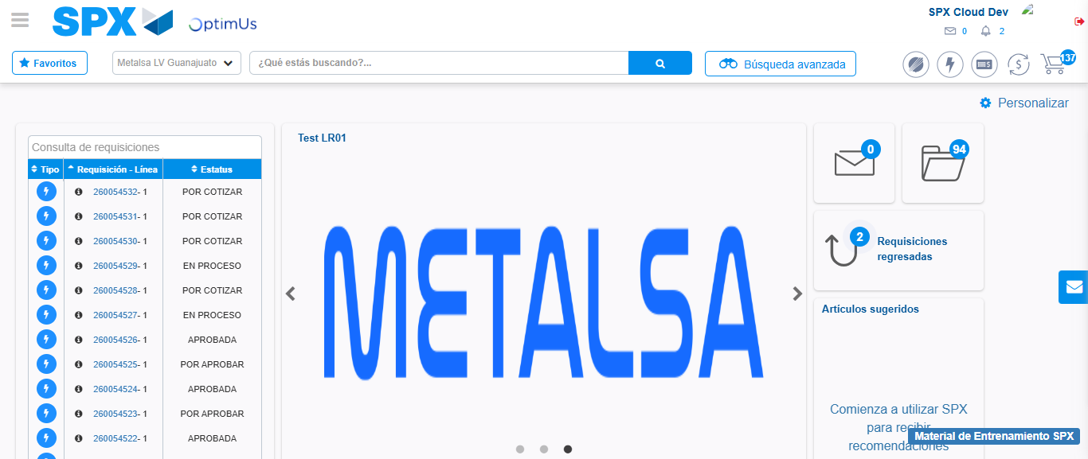Image file-name: QC_Testing-tc003_SPX_Dev5_Crear_Requisicion_Spot_Tipo_Cobro_CC_Urgent-1782239446561

